Student Name : SOH ZU WEI

Group : A21

Date : 19/3/2023

LAB 4: ANALZING NETWORK DATA LOG

You are provided with the data file, in .csv format, in the working directory. Write the program to extract the following informations.

Exercise 4A: TOp TALKERS and LISTENERS

One of the most commonly used function in analyzing data log is finding out the IP address of the hosts that send out large amount of packet and hosts that receive large number of packets, usually know as TOP TALKERS and LISTENERS. Based on the IP address we can obtained the organization who owns the IP address.

List the TOP 5 TALKERS

Rank | IP address | # of packets | Organisation
1
2
3
4
5

TOP 5 LISTENERS

Rank | IP address | # of packets | Organisation
1
2
3
4
5

Exercise 4B: TRANSPORT PROTOCOL

Using the IP protocol type attribute, determine the percentage of TCP and UDP protocol

 | Header value | Transport layer protocol | # of packets
1 | 6 | TCP (6) | 879 (73.25%)
2 | 17 | UDP (17) | 135 (11.25%)
3

Exercise 4C: ApplicationS PROTOCOL

Using the Destination IP port number determine the most frequently used application protocol.
(For finding the service given the port number https://www.adminsub.net/tcp-udp-port-finder/ )

Rank | Destination IP port number | # of packets | Service
1 | 443 | 234 | https
2 | 0 | 82 | ???
3 | 56152 | 82 | Dynamic and/or Private Ports
4 | 43930 | 45 | Unassigned
5 | 80 | 37 | http

Exercise 4D: Traffic

The traffic intensity is an important parameter that a network engineer needs to monitor closely to determine if there is congestion. You would use the IP packet size to calculate the estimated total traffic over the monitored period of 15 seconds. (Assume the sampling rate is 1 in 2048)

Total Traffic( MB)

Exercise 4E: ADDITIONAL ANALYSIS (SEE NEXT PAGE for 4E FINDINGS)

Please append ONE page to provide additional analysis of the data and the insight it provides.
Examples include:
Top 5 communication pairs;
Visualization of communications between different IP hosts;
etc.

Please limit your results within one page (and any additional results that fall beyond one page limit will not be assessed).

Exercise 4F: SOFTWARE CODE

Please also submit your code to the NTULearn lab site.
Exercise 4E: ADDITIONAL ANALYSIS

Get the top communicating IP address pairs (src IP and dest IP)
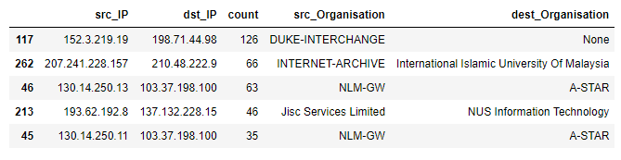
By identifying the top 5 communication pairs, we can figure out who are the users who are talking to each other the most based on their ip addresses. Subsequently, with the top communication pairs, we could also check which organisation those IP addresses belong to, and this would allow us to visualise organisations who are talking to each other.

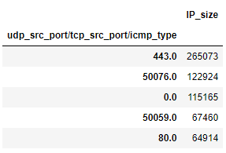
Finding out ip addresses and ports who have sent the most amount of data over the network.
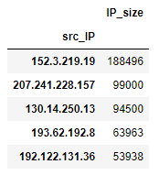

Top 5 IP address with the most IP data sent. Top 5 src port with most IP data sent.

This could be useful to discover and understand which users or applications are sending the most data over the network, potentially hogging the network. With this information, we could also discover anomalies and act upon them, such as finding out if an application/user is using up or sending too much data, thereby closing/stopping them if necessary.

Visualising the communication between IP addresses.

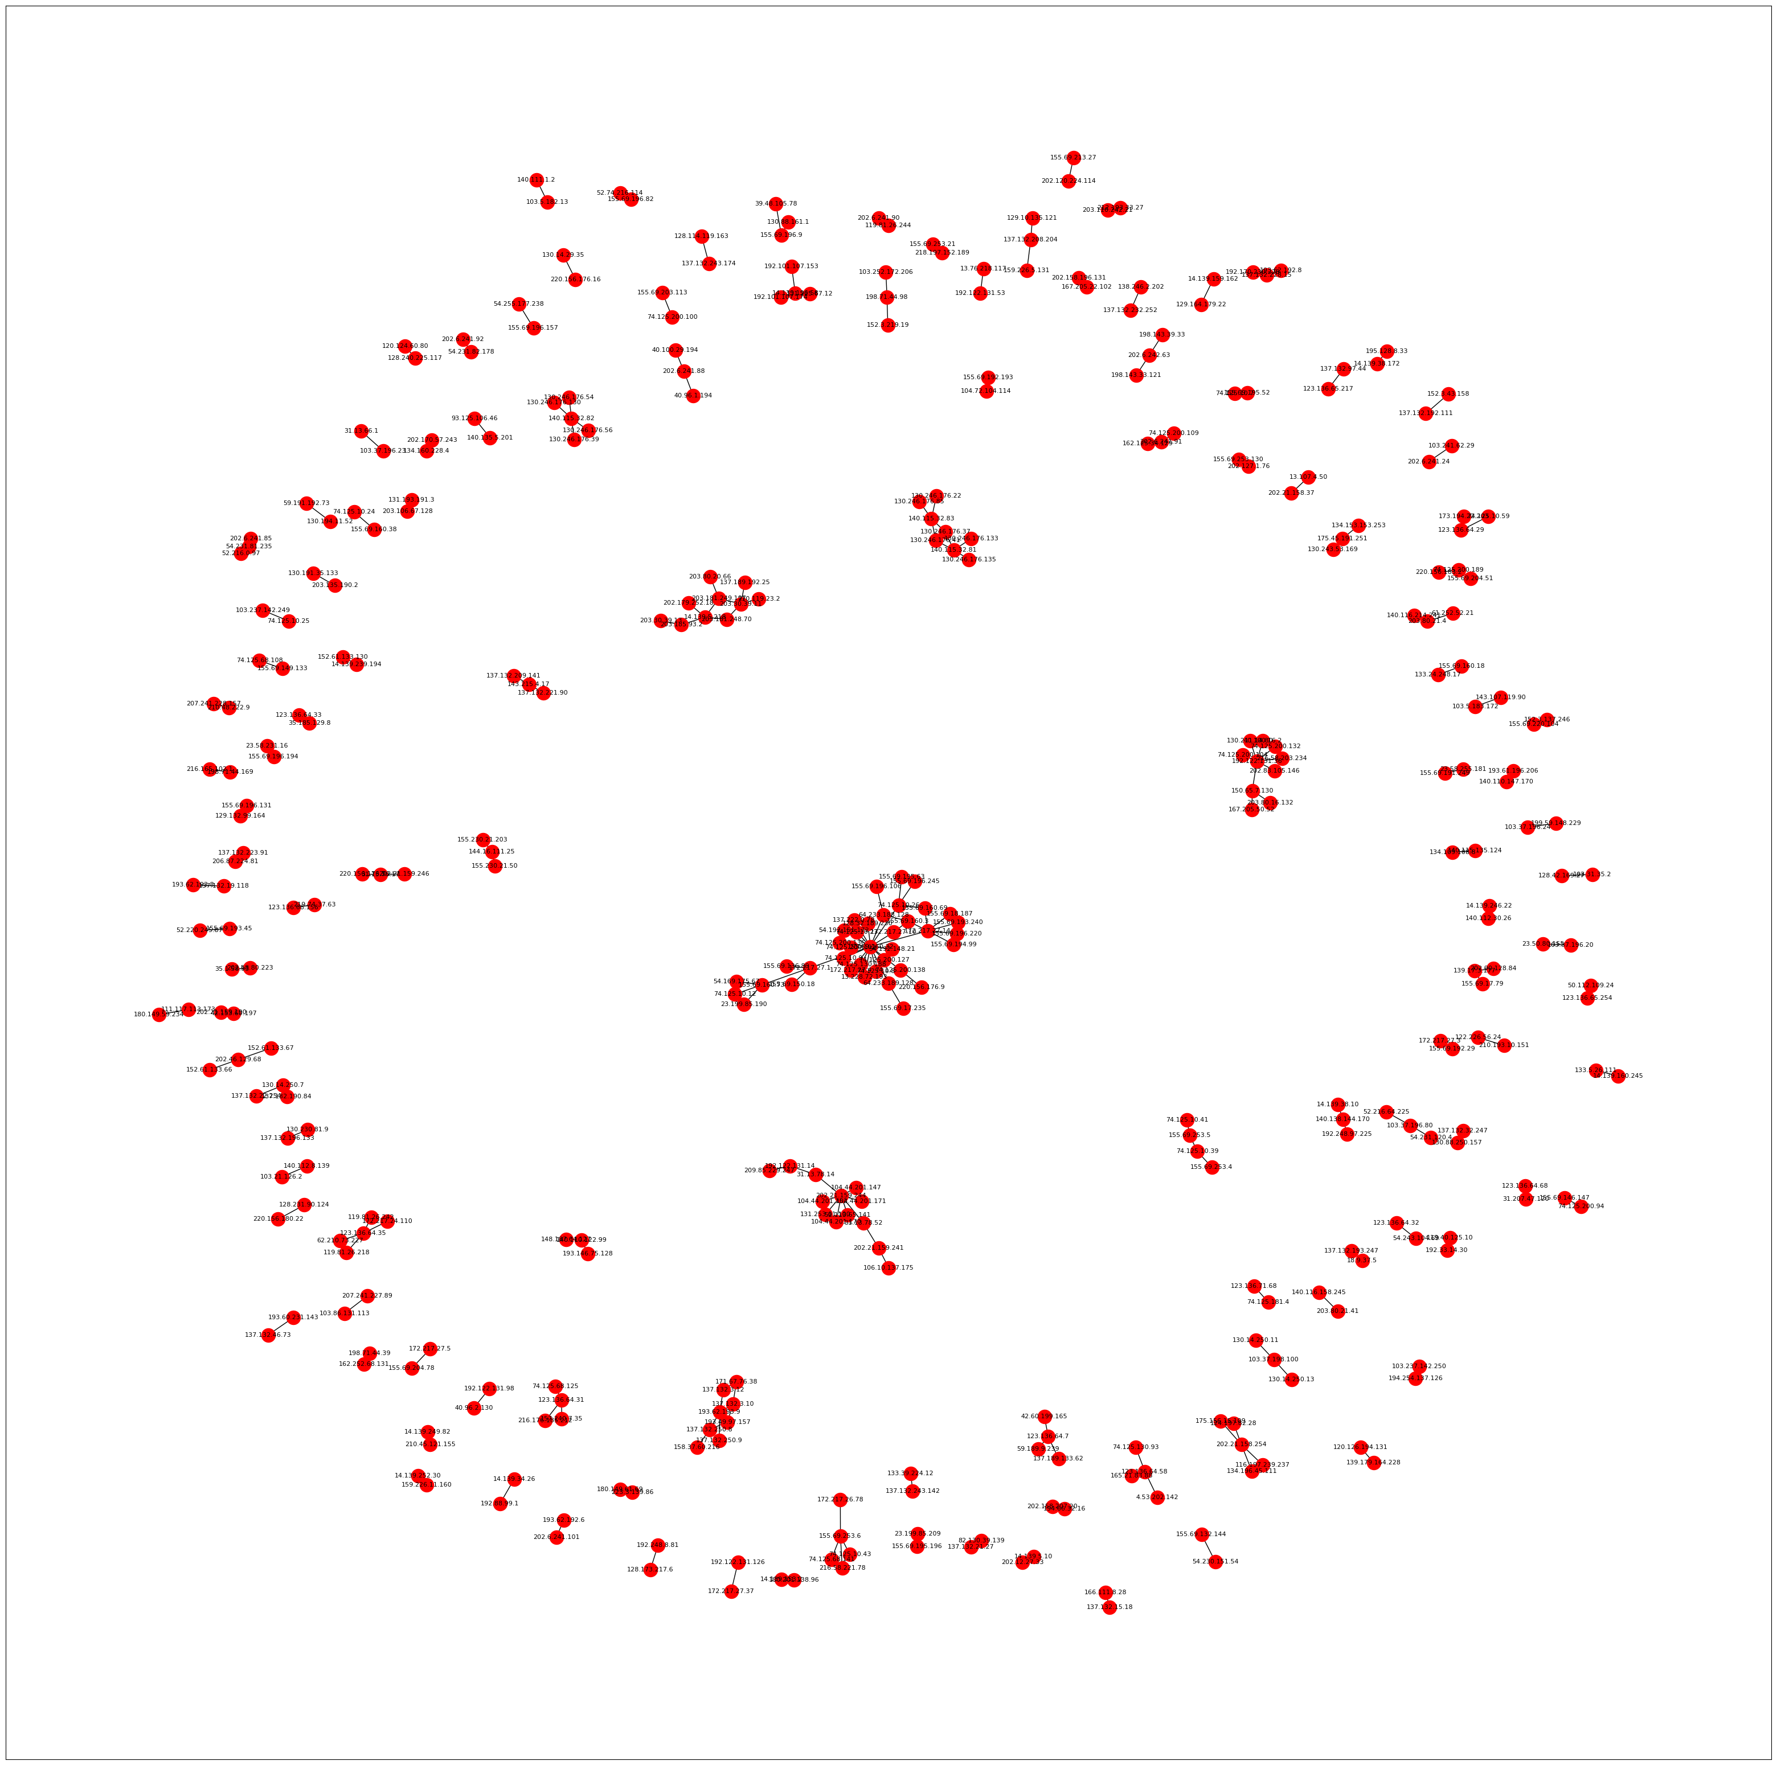
By visualizing the communications between IP addresses as graph nodes, we can quickly see which IP addresses communicate with each other.

In addition, we could also see relationships between different IP addresses, for example we could see nodes who only communicates with each other (only two connected nodes) and we can also quickly see bigger relationships such as the subgraph in the center with multiple connected nodes.

This could help to identify potential bottlenecks, security issues (e.g., where an ip address should not be speaking to another specific ip address) and other areas that could require optimization.

